BÁO CÁO THỰC HÀNH LAB 1  
LẬP TRÌNH HƯỚNG ĐỐI TƯỢNG

# The Very First Java Programs

## *2.2.1* Write, compile the first Java application:

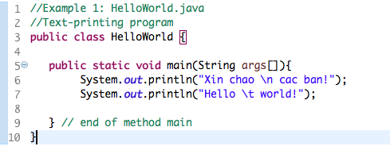

*Kết quả*

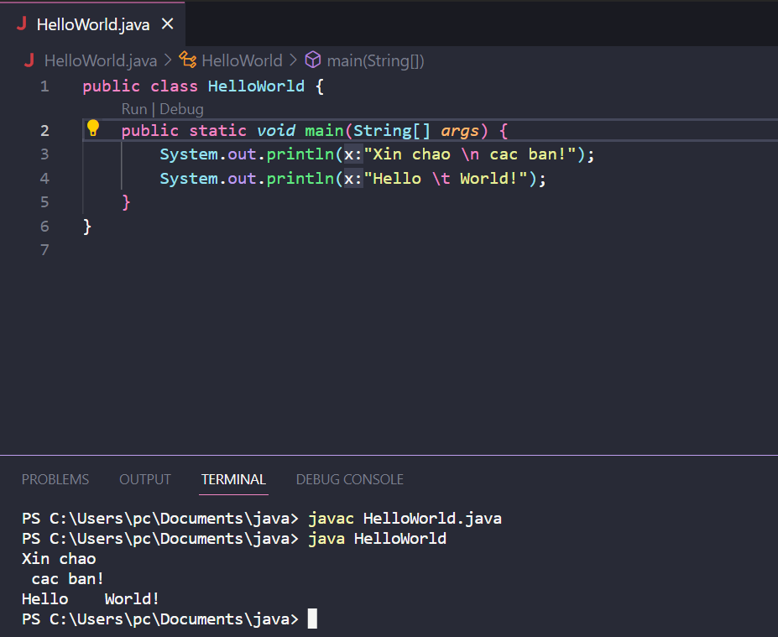

## 2.2.2 Write, compile the first dialog Java program

### Screen Shot 2019-02-12 at 12

### 

## 2.2.3 Write, compile the first input dialog Java application

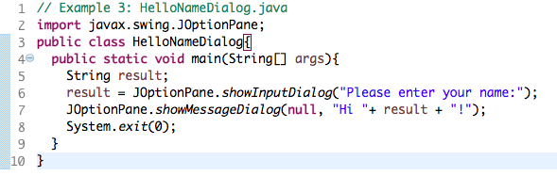

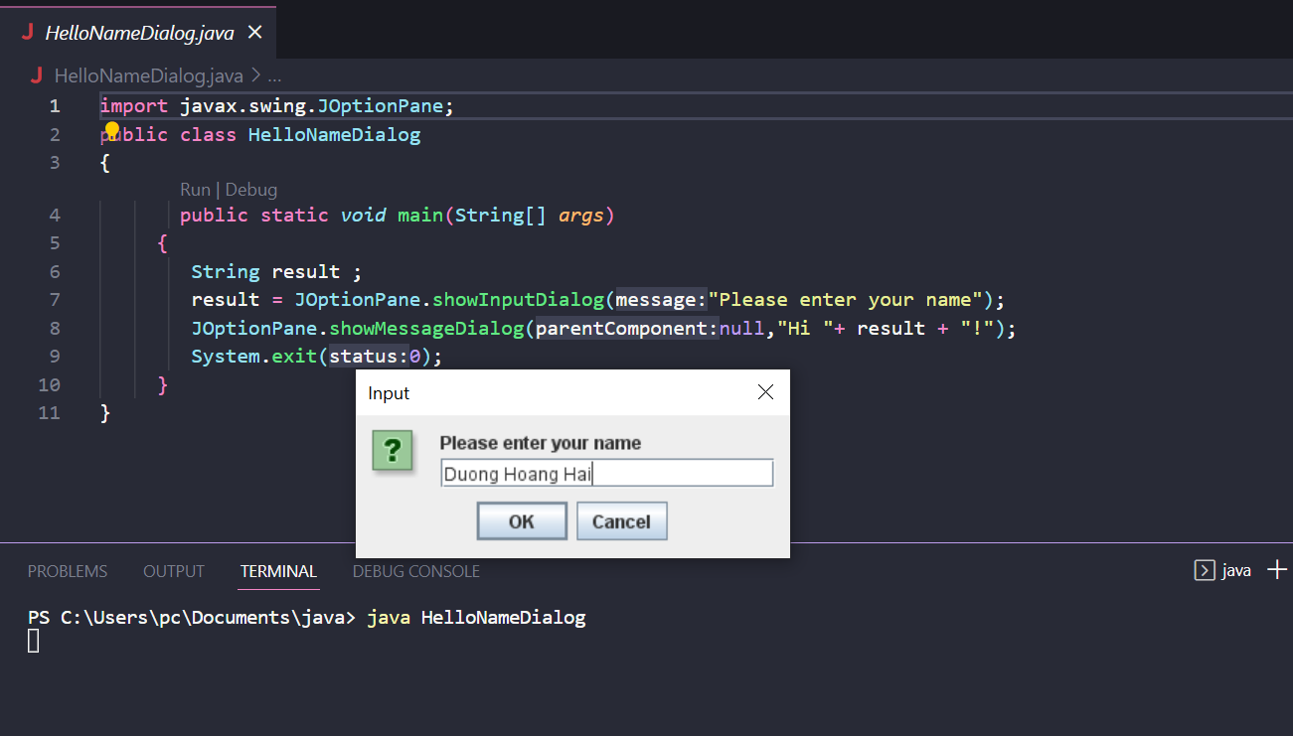

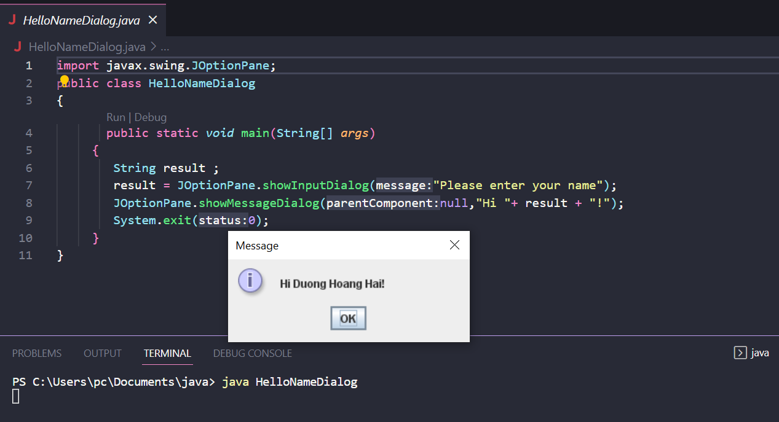

## 2.2.4 Write, compile, and run the following example:

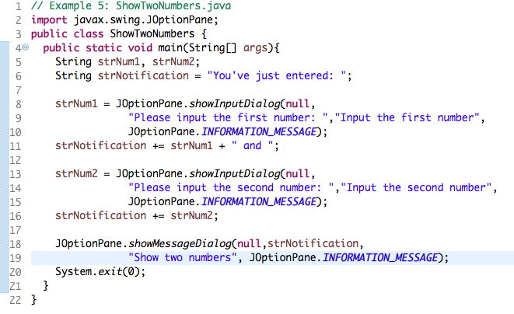

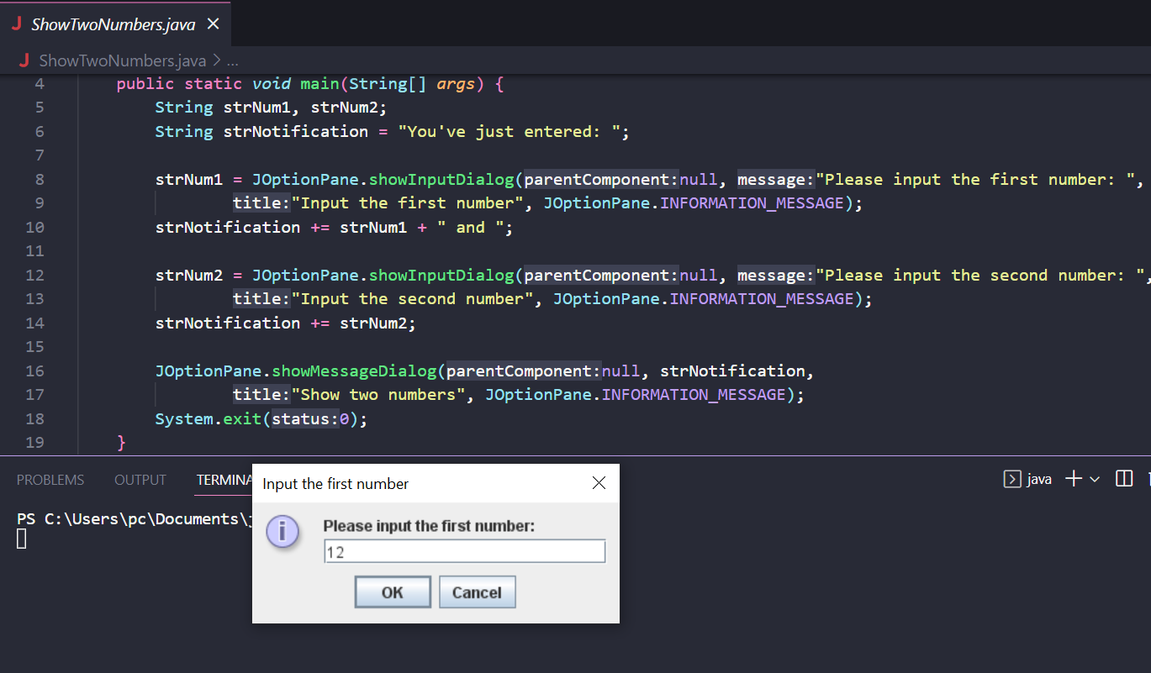

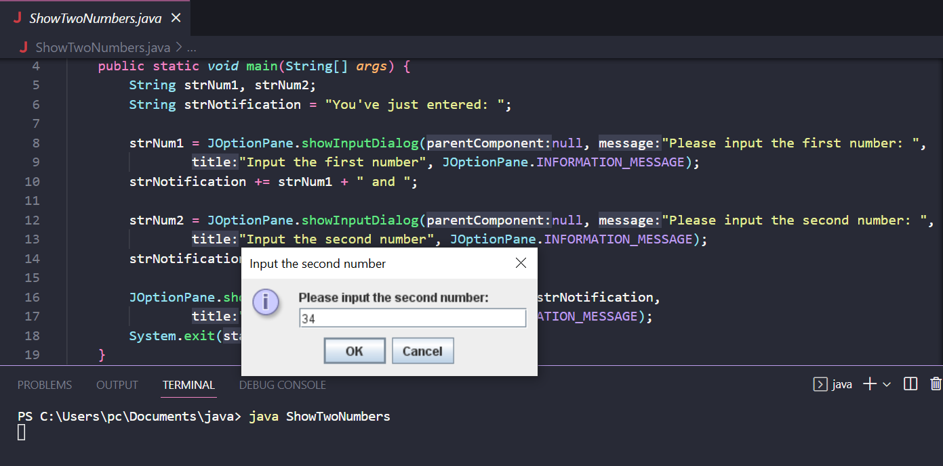

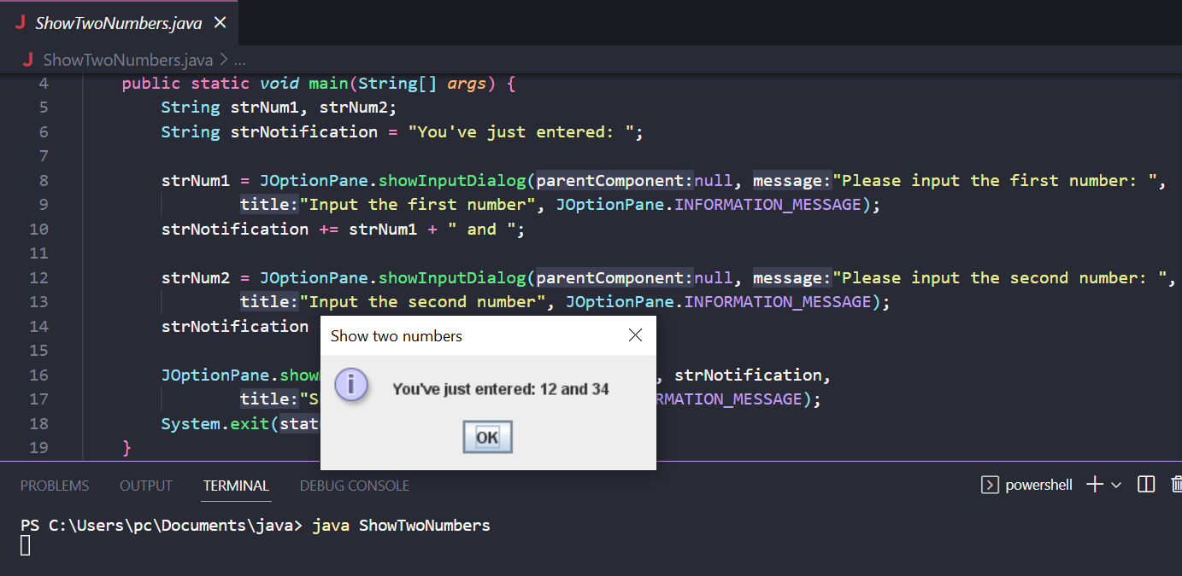

## 2.2.5 Write a program to calculate sum, difference, product, and quotient of 2 double numbers which are entered by users.

**Notes**

* To convert from String to double, you can use

**double num1 = Double.parseDouble(strNum1)**

* Check the divisor of the division

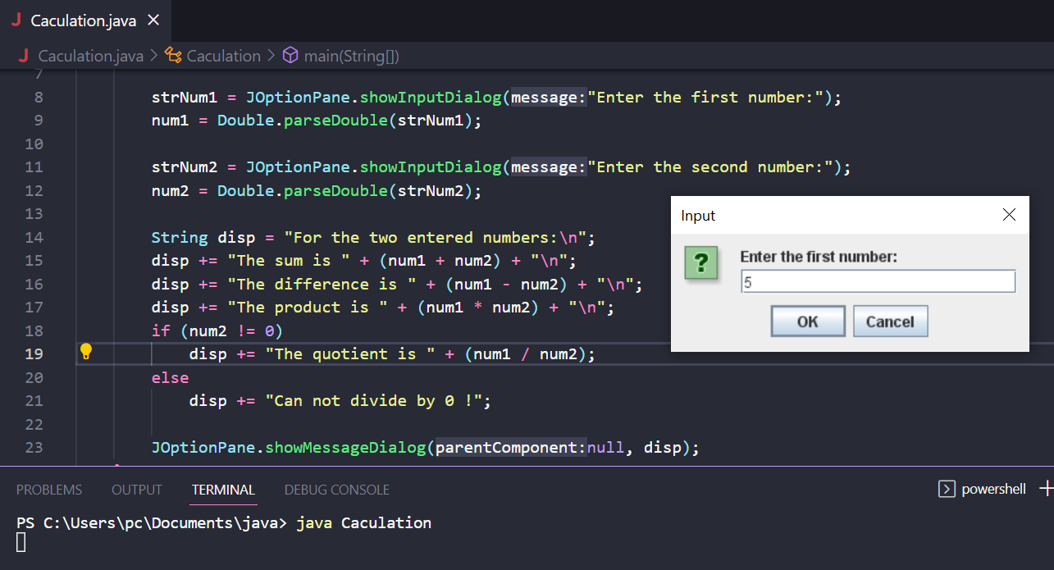

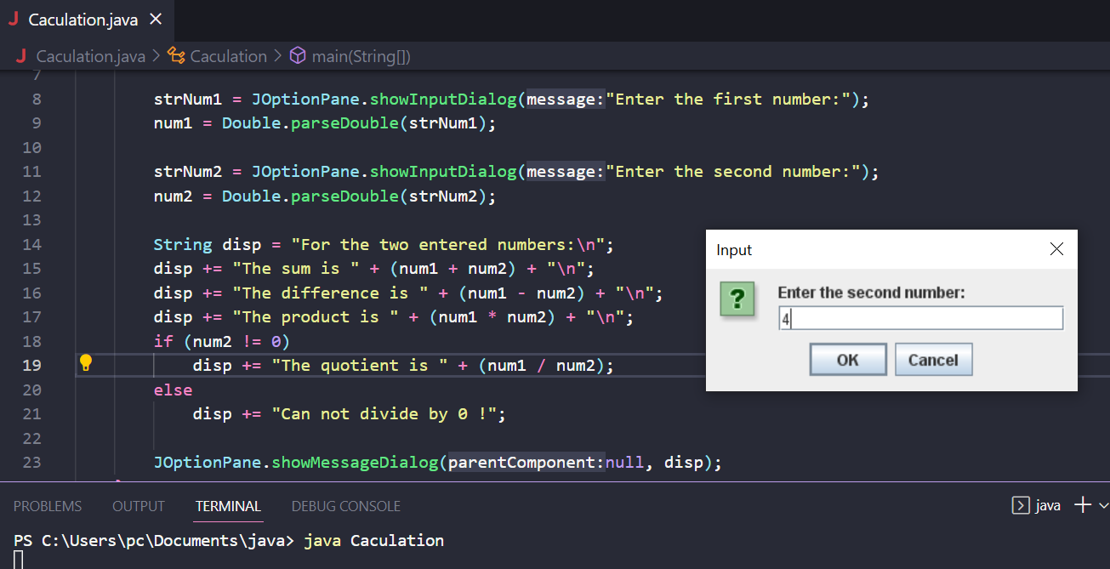

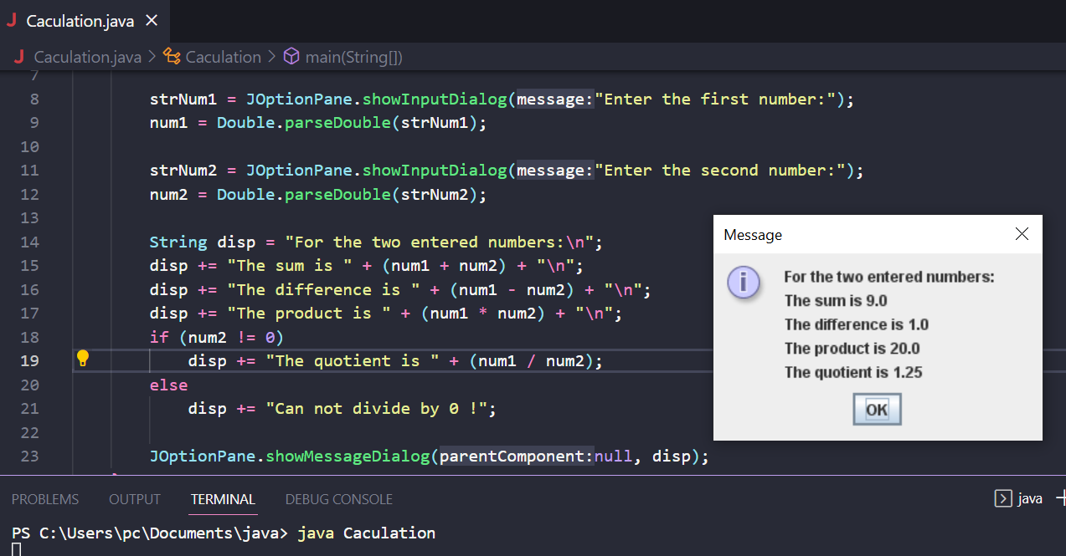

## 2.2.6 Solving equations and system of equations

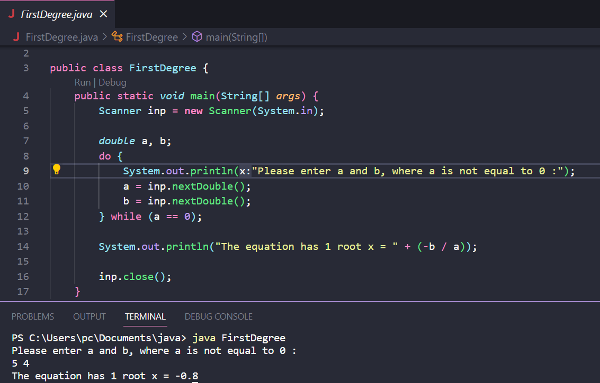

First-degree equation

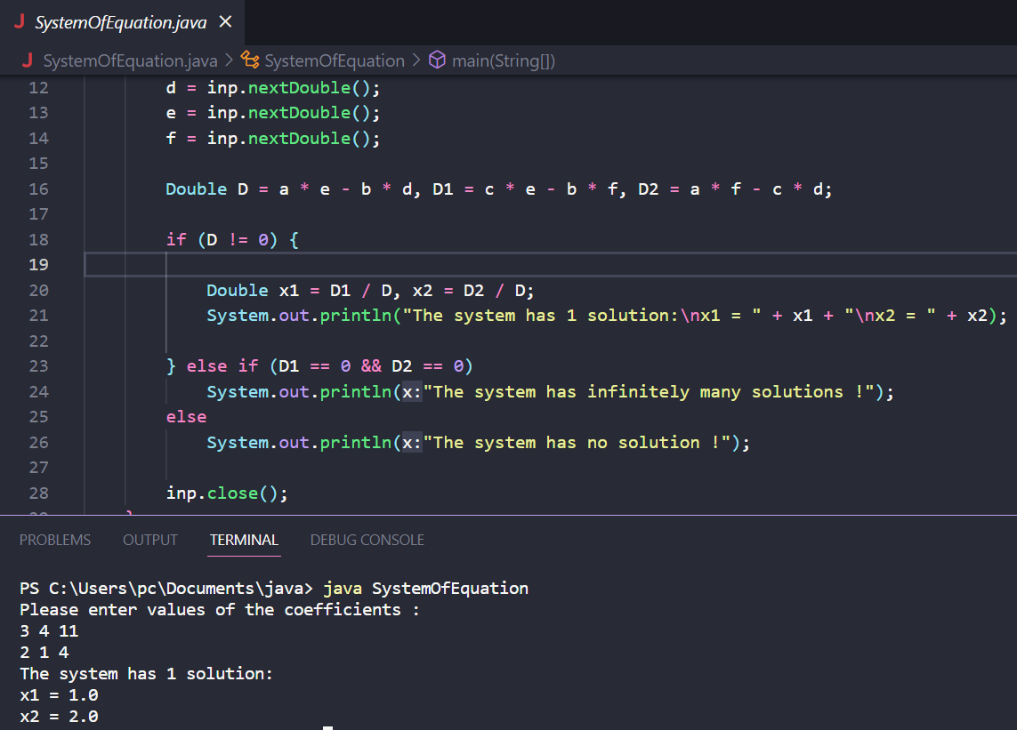

System of first-degree equations

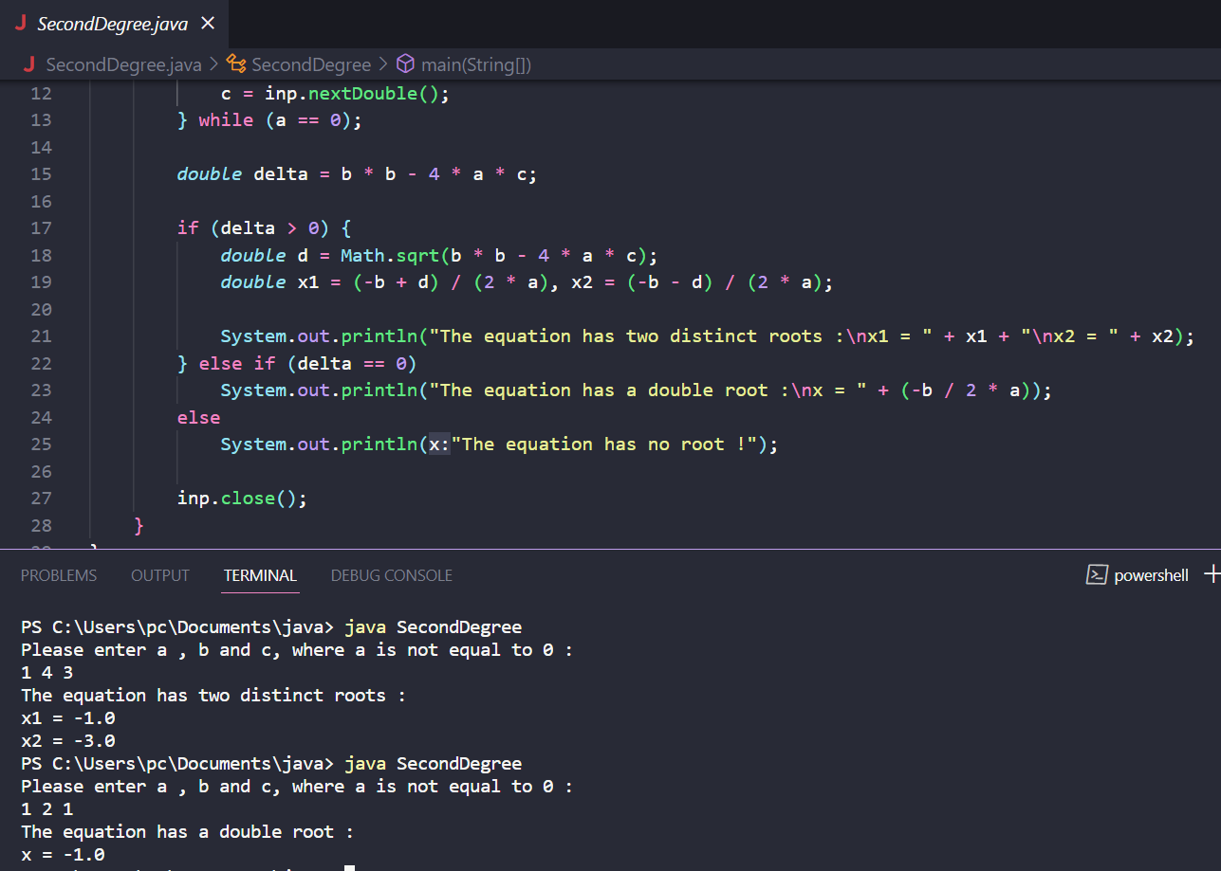

Second-degree equation

## 6.1 : Write, compile and run the ChoosingOption program

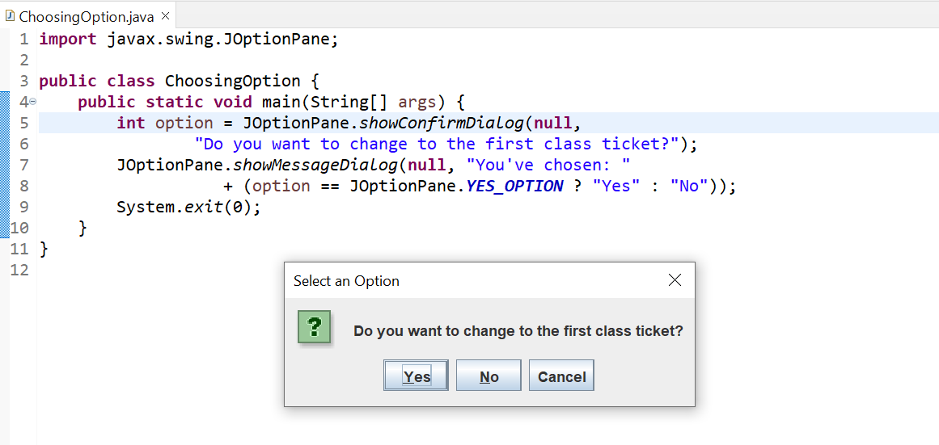

## 6.2 Write a program for input/output from keyboard

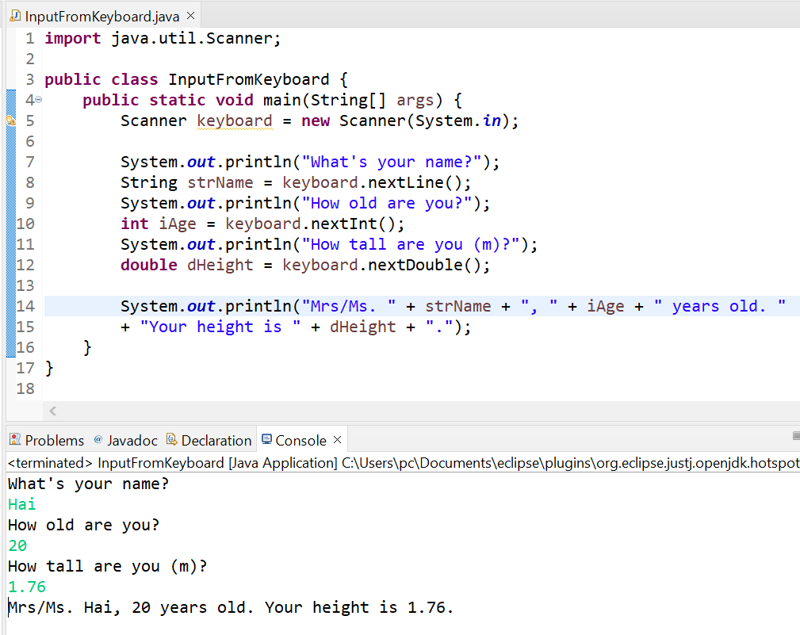

## 6.3 Write a program to display a triangle with a height of n stars (*), n is entered by users

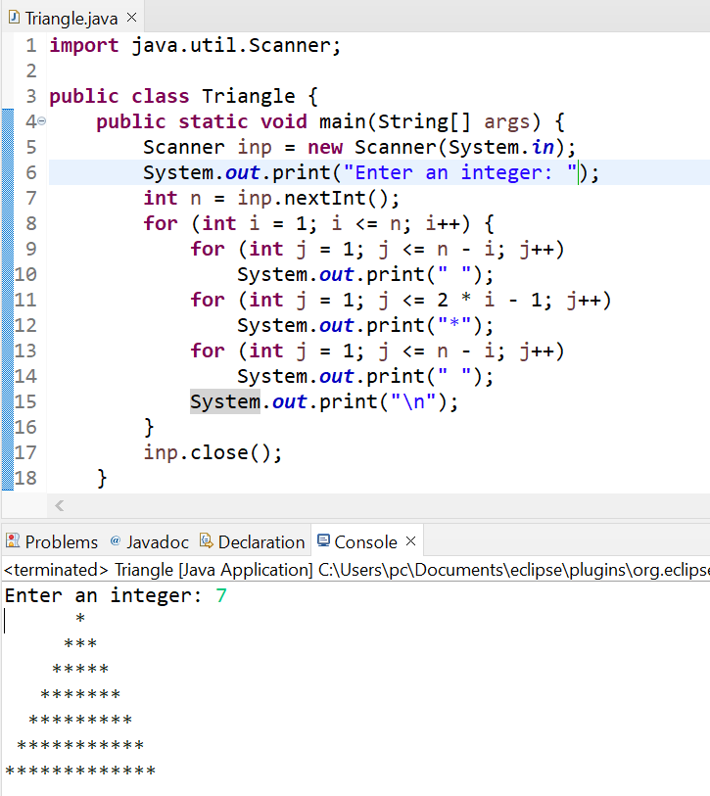

## 6.4 Write a program to display the number of days of a month, which is entered by users

## (both month and year). If it is an invalid month/year, ask the user to enter again

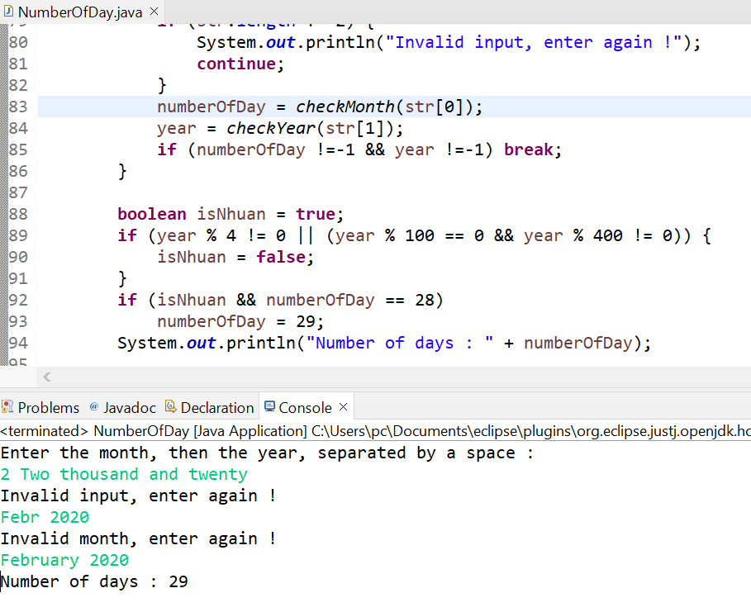

## 6.5 Write a Java program to sort a numeric array, and calculate the sum and average value of array elements

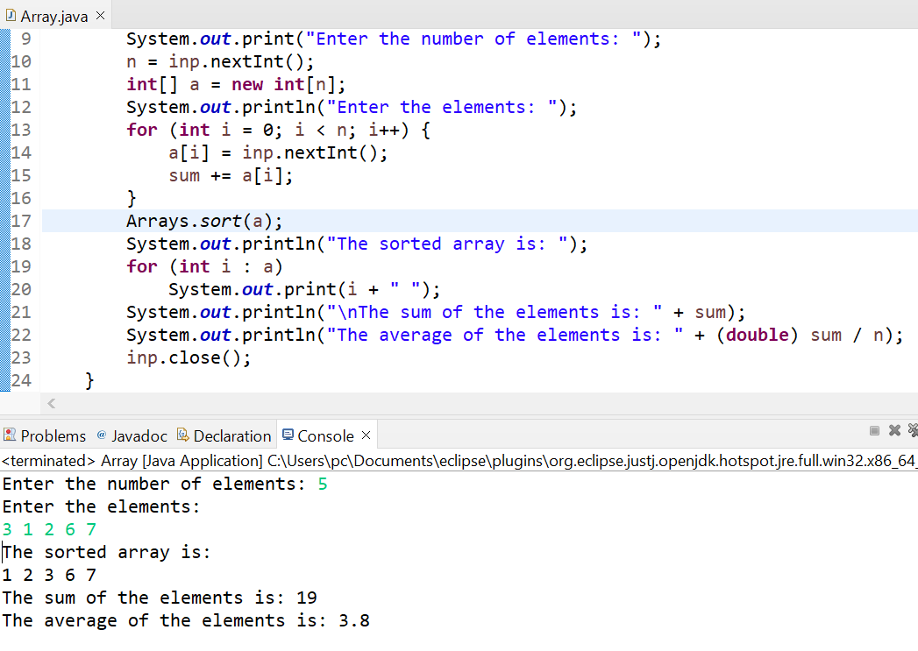

## 6.6 Write a Java program to add two matrices of the same size

